Resume Builder Web Application Increment-04

**Team Leader:** Ravi Krishna Teja Dachepalli (16300464)

### Team members:

1. Jayanth Golla
2. Ravi Krishna Teja Dachepalli 3. Anudeep Thippireddy
3. Manoj Desetty

### Project Description (Background Story):

For any working individual in any business, creating a resume is a time - consuming effort. It must be kept short, straightforward, and current with work experience, and it must be updated on a regular bas is.

This project will guide you through the steps necessary to create a resume builder using ReactJS and NodeJS. Implementing the project will provide you the satisfaction of being able to generate it on your own while also assisting working pros.

The main objective is to develop a web application that will auto -generate a nice and properly formatted Resume from the information filled up in a form.

Here the resume contains,

* + Contact Information.
  + Career Objective.
  + Skills and Abilities
  + Work experience
  + Educational qualifications

### Project Workflow:

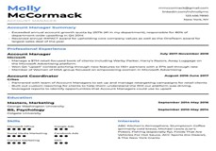

S e t t i n g U p P r o j e c t b y I n s t a l l i n g

N e c e s s a r y

C r e a t e C u s t o m C o m p o n e n t s f o r u s e r i n p u t f o r

S t y l i n g t h e

C o m p o n e n t s

u s i n g M a t e r i a l s

D o w n l o a d i n g t h e P D F F i l e f o r

U s e r

P a s s i n g t h e

i n f o r m a t i o n t o t h e

s e r v e r a n d s t o r i n g i t

There are different stages involved in creating this web application which gives us some good resume pdf documents as output through the process that can be followed to build your resume- builder using ReactJS and NodeJS.

### Stage 1:

The first step is installing react on your system using and creating new react applications using various tools. Basically, this step is installing all the required environments for the project.

The first step is setting up an environment which is required for building an application. We start it by installing a platform i.e Webstorm or Visual Studio.

### Stage 2:

In this stage, we need to build components which take the User input and store them in a form which was used for building a good resume.

Resume Builder contains the following columns as different input fields requested from the user. All these columns together form a data set that is required to build a resume of the user.

**Table showing basic user inputs and their data type**

|  |  |  |
| --- | --- | --- |
| Input | Data type of the input | User Reply |
| Image | .jp or .jpeg |  |
| First Name | text |  |
| Middle Name | text |  |
| Last Name | text |  |
| About (< 50 words) | text |  |
| Date of Birth | date |  |
| Address | text |  |
| Email Id | text |  |
| Contact | number |  |
| Highest Degree | text |  |
| Date of Highest Degree | date |  |
| Score of Highest Degree | number |  |
| Experience | number |  |
| Technical Skills | Text |  |
| Certifications (if any) | Text or URL |  |
| Previous Company | text |  |

|  |  |  |
| --- | --- | --- |
| Publications (if any) | Text or URL |  |
| Personal Blog | Text or URL |  |
| Social Media | Text or URL |  |
| Awards | Text |  |
| Leadership Skills | Text |  |

### Stage 3:

Here, the output of the stage 2 is styled by using Styling components like Bootstrap and CSS components.

### Stage 4:

The styled components are passed to the server and stored in an user selected template.

### Stage 5:

In this stage, the resume template is available in PDF format which can be easily downloaded by the user by clicking on a button.

# Application working behind the scenes:

1. Users will visit the front-end website built by react.
2. When user enters the data, the frontend will connect with the API endpoints generated by NodeJS and stores the data in Firebase.
3. NodeJS will query the Firebase database and return the results to the frontend.
4. Firebase Database will load the data from the user input data into the database on a regular basis.
5. The result of the frontend is a well-designed resume which will be available in PDF format and it can be downloaded on a single click.

# Data and its Flow:

## Here the data is Users Input. User’s input is taken as raw data and this data will be formatted to give a resume that can be used to apply to various jobs.

* The data is completely about the user and the user enters the data in the provided HTML input areas.
* This project doesn’t need any sampling as the user gives only the requested data.
* This data will be fresh for every user and this application will not be working with any global or previous data.
* This data doesn’t contain geographical information or any other factors like regional, national, or global as the data is user specific.

# Working Screens and Features of Application:

* 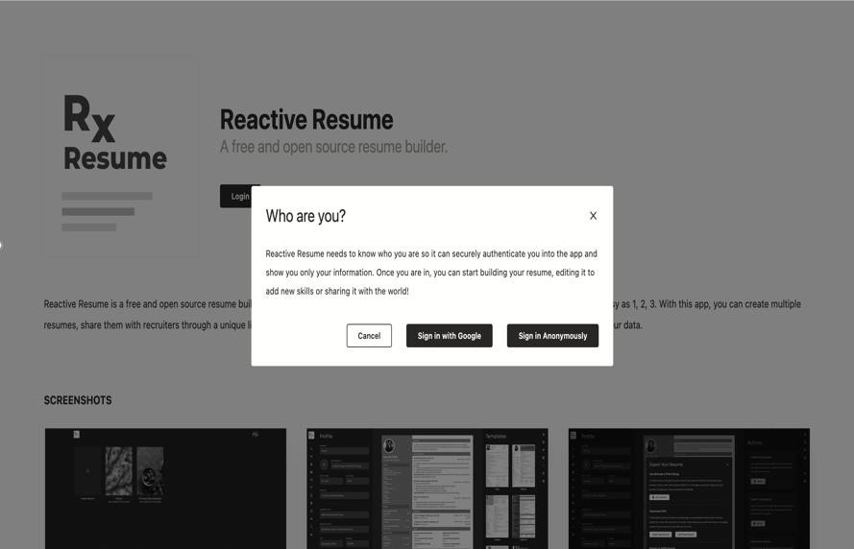User Authentication: User can create an account or sign in through Gmail or sign in anonymously

**User Auth Screen**

* Following image is the Main screen, where user can fill out the details for our resume.
* 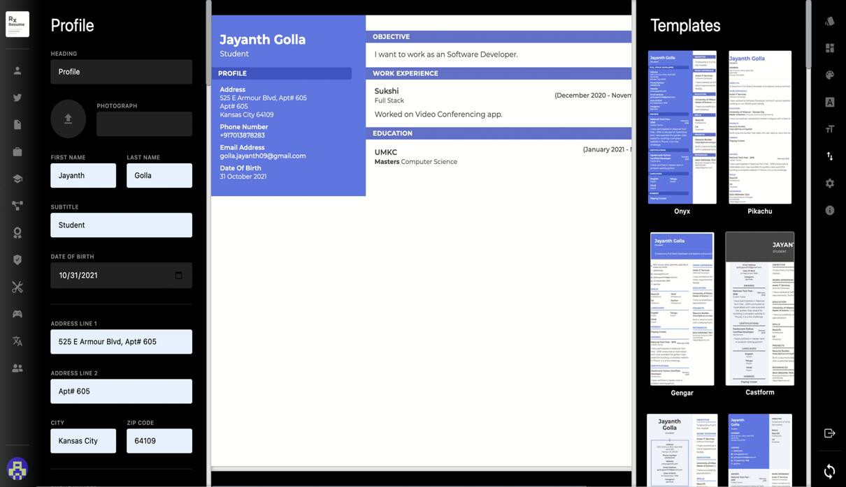This data will be used to build resume in different templates according to the user selection.

Main Screen

* 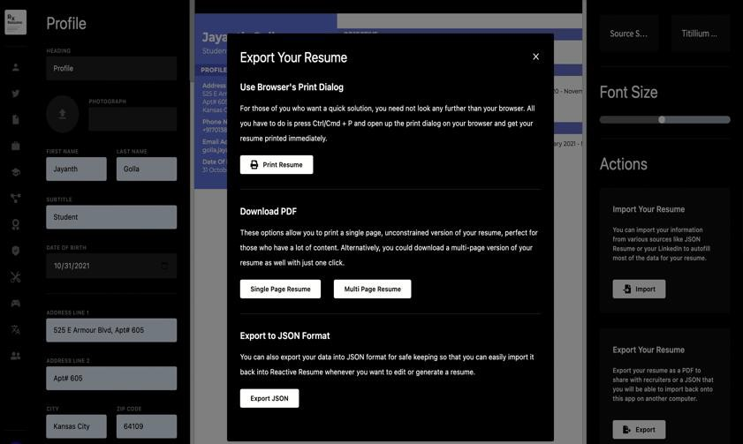Another important feature is that user can import, export, print and download resume. This enables user friendly experience.

**Print Screen**

* User can select any template out of the 6 provided templates.
* User can change the color of the template.
* User can access font, font size, layout colors etc. in the side bar provided.

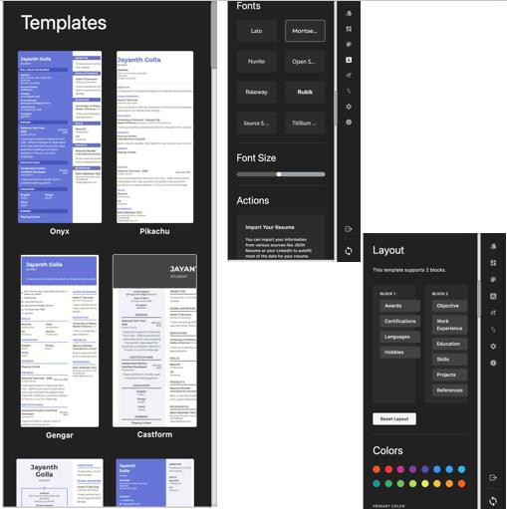

**Template and Side Bar Screen**

# Database:

## Firebase Realtime Database is used to store the data and database schema is created according to the requirement.

**Firebase Main Screen**

* For Authentication, you can login through Gmail or Anonymously. The following picture displays the list of users auth data stored in the

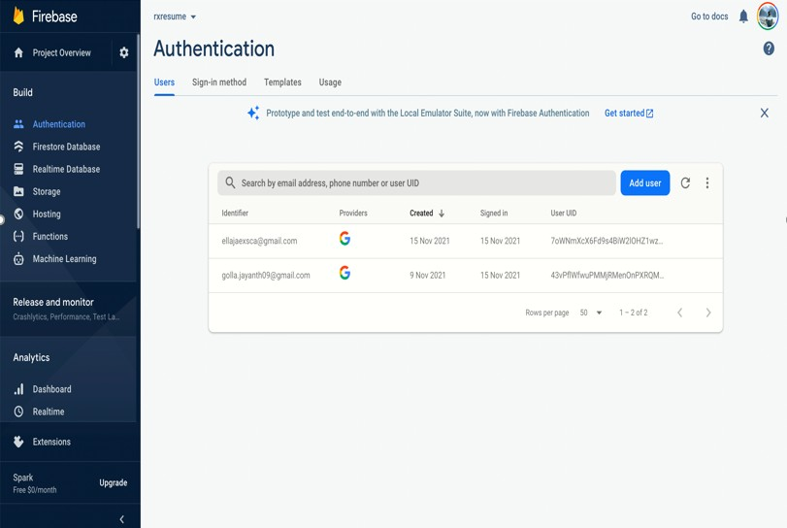database.

**User Auth Data in Firebase**

# Code Snippets

# Following code snippet is related to the information of user profile. It seeks all the required information from the user and this data will be stored in to obtain resume in required template/format.

# 

# Resume Creation

# Following code snippet is related to the templates that helps to build resume from user given data. This consists of all the templates, and it is responsible for inserting the data into template opted by the user.

# 

# Resume Preview

# Following code snippet is related to the firebase where data and user information is stored in the schema created.

# 

# Firebase

# Issues:

* Establishing proper connection with Firebase Realtime Database
* Creating appropriate schema in the database
* Issues with cascading style sheets while designing the website.

# Work Distribution:

* Front end: Anudeep & Jayanth
* Back end: Jayanth, Manoj, Anudeep & Ravi
* Documentation: Ravi

**GitHub URL:** [https://github.com/ravi4080/Resum eBuilder](https://github.com/ravi4080/ResumeBuilder)

**Presentation URL:** <https://github.com/ravi4080/ResumeBuilder/blob/main/Documentation/Final%20Presentation/Team-01-Final-Presentation-Resume%20Builder.pdf>

**Video URL:** <https://umsystem.hosted.panopto.com/Panopto/Pages/Viewer.aspx?id=78bbb867-8c2b-4235-ad49-ade101309e7c>

# References:

* Resume Genius: [https://resu megenius.co m/](https://resumegenius.com/)
* Article: [http://www.prosperoverseas.com/sample-resu me](http://www.prosperoverseas.com/sample-resume)
* Firebase Article: [https://css-tricks.co m/intro-firebase-react/](https://css-tricks.com/intro-firebase-react/)
* Resume Templates: [https://novoresu me.co m/resu me-templates](https://novoresume.com/resume-templates)